Citation note:
We used ChatGPT to help debug and ask questions regarding pytorch documentation / syntax. Further, we followed an example of the DCGAN implementation found in the PyTorch docs. Other citations are in the readme below and some are mentioned in the comments of the .ipynb notebook itself.

Assignment 3 practical Question 5
A reimplementation of two distinct Generative Adversarial Network (GAN) architectures using various techniques described in "Improved Training of Wasserstein GANs", by Gulrajani et al. (2017). We add to this paper by testing two architectures with three techniques each (DCGAN, WGAN (weight clipping), and WGAN (gradient penalty)). We work with the FashionMNIST dataset to generate images with generator networks after training is complete.

See https://arxiv.org/abs/1704.00028

Content Overview
This project includes a Jupyter Notebook file which creates a training regime for evaluating different models and techniques applied to GANs that generate images based on the FashionMNIST dataset. Specifically, we chose 2 architectures and trained a Deep-Convolutional GAN (DCGAN), a Wasserstein GAN with weight clipping, and a Wasserstein GAN with gradient penalty applied.

Dependencies
All dependencies are imported within the markdown file. Simply run the file to import the correct packages. It is recommended to connect to an NVIDIA T4 GPU for training these models. Note that the folder includes model weight paths that can be imported for generation. Please use Python 3.10+

Data Upload
We decided to use “wget” so that we can retrieve the dataset easily whenever we run the notebook. After importing the dataset, we build a dataset class and normalize the pixel values to [0, 1]. We also convert images to 64x64 tensors normalized to [-1.1].

Key Functions and Classes

'weights_init'
The 'weights_init' function is called to initialize the weights of the layers in our networks prior to training. This function initializes convolutional layers and batch normalization layers properly. This ensures that the network begins with appropriate parameters for stable learning.

‘Generator’
The ‘Generator’ class defines a python nn.module for the DCGAN generator. As input, the model takes a random noise vector. The model includes 4 convolutional layers, each with batchnorm and ReLU, followed by a Tanh layer at the end. The output is an image of size 64X64 with a variable number of channels (for RGB if necessary).

‘Generator_WGAN’

The ‘Generator_WGAN’ class defines a python nn.module for the WGAN generators.This is functionally the same as the ‘Generator’ class.

‘Critic_WGAN’

The ‘Critic_WGAN’ class defines a python nn.module for the WGAN with weight clipping critic / discriminator. The ‘Critic_WGAN’ is functionally very similar to the ‘Discriminator’ class with, but there is one key difference. The critic outputs a raw scalar value (without sigmoid) which makes it suitable for the Wasserstein approach.

‘Critic_WGAN_GP’

The ‘Critic_WGAN_GP’ class defines a python nn.module for the WGAN with gradient penalty critic / discriminator. The ‘Critic_WGAN_GP’ is functionally very similar to the ‘Critic_WGAN’ class with, but it uses layernorm (more below) rather than batchnorm for stabilization. The critic also outputs a raw scalar value (without sigmoid) which makes it suitable for the Wasserstein approach.

'Discriminator'
The Discriminator class defines a python nn.module for the DCGAN discriminator. As input, the model takes an image (64 x 64 x number of channels). The model includes 4 convolutional layers, each with stride 2, reducing the size of the image. The layers use LeakyReLU and batchnorm (besides the first layer). The output is a singular scalar from a final sigmoid layer, and this represents the probability that the input is real.

‘load_generator_weights’
This function takes in a generator model nn.module class as well as a file path in order to apply the saved weights from trained model to the passed-in model. This allows for inference – or generation – without the need to retrain the model everytime the notebook restarts.

'generate_and_show_image'
This function takes in a generator model nn.module class as well as a file path, the size of the noise vector (latent space) and the device (CPU / CUDA) in order to apply saved weights to a generator model that is passed-in. Next, the function generates an image from this generator. This function is used to generate with the GANs without needing to run training every time the notebook restarts.

‘LayerNorm2d’

This class defines a custom layer normalization layer for 4d tensors, applied independently over each channel. This is used to help stabilize training by ensuring consistent activations without needing to rely on batch statistics

How to Train the GANs
In order to run our cells for training, it is required that all importing and data processing cells are run and the necessary pre-train tasks are complete. These pre-train tasks include initializing the criterion, fixed noise vectors, the save path for the generator weights, the lists to store the images generated (for analysis), and the generator and discriminator loss lists.

To train the GANs now, simply run the designated training block within the section that you want to train (i.e. Architecture I, WGAN (with weight clipping). Following the training block, there are some visualizations set up in subsequent blocks to show the generator / discriminator loss, a comparison between real and generated images (with weights from final epoch), and a training walkthrough animation to show the generation progress of the generator at each step in the training.

How to Generate with GANs

The exciting part is using the trained generator networks to generate new images. In order to make it easy on the user of this repository, the .pth files that include each generator’s trained weights are included in the primary folder and can be imported for easy generation with the model and architecture of your choice.

For loading weights and generating images with one of the GANs, use the code below for guidance.
- Instantiate the desired generator model (note, the generator model nn.module class and its dependencies must be instantiated prior)
- Provide the path to the desired model weight file
- Give the noise vector size (100)
- Provide the device
- Run the generate_and_show_image function with appropriate arguments

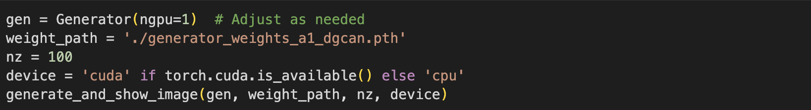
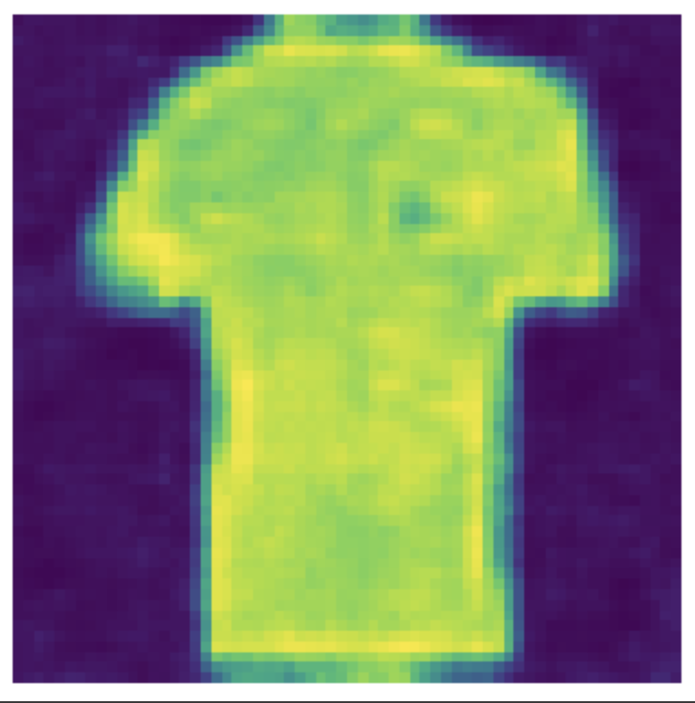

Architectures
Architecture 1:

- Nonlinearity (G): ReLU
- Nonlinearity (D) : LeakyReLU
- Depth (G): 4
- Depth (D): 4
- Batch normalization (G): True
- Batch normalization (D); layer norm for WGAN-GP: True
- Base Filter Count (G): 64
- Base Filter Count (D): 64

Architecture 2:

- Nonlinearity (G): ReLU
- Nonlinearity (D) : LeakyReLU
- Depth (G): 4
- Depth (D): 4
- Batch normalization (G): True
- Batch normalization (D); layer norm for WGAN-GP: True
- Base Filter Count (G): 32
- Base Filter Count (D): 32

Analysis

Number of failed convergences

For both architectures, the only convergence that failed the first time was for the WGAN-GP model. We had to tweak the beta values and learning rate – aligning it to the paper’s parameters for WGAN-GP – in order to see convergence. Notably, we could not get the generator loss to trend towards 0, and it behaves like a non-decreasing function for both architectures; however, the images generated by the generator were legible and good enough to ensure that the GAN approach was working, and the generator was learning to mimic the train images well.

Architecture 1

DCGAN Images
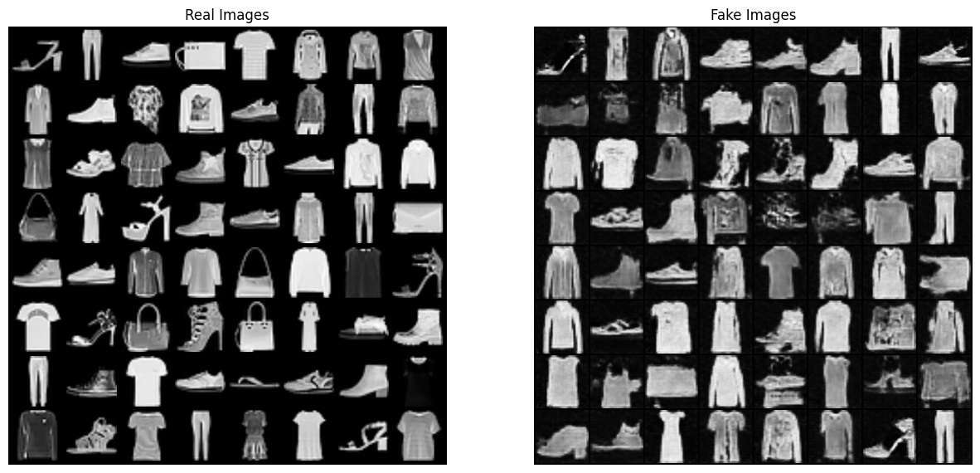
WGAN (with weight clipping) images
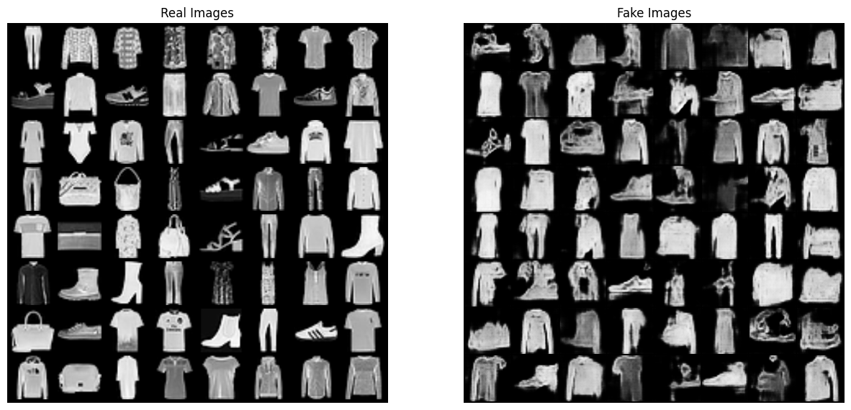

WGAN-GP (with gradient penalty) images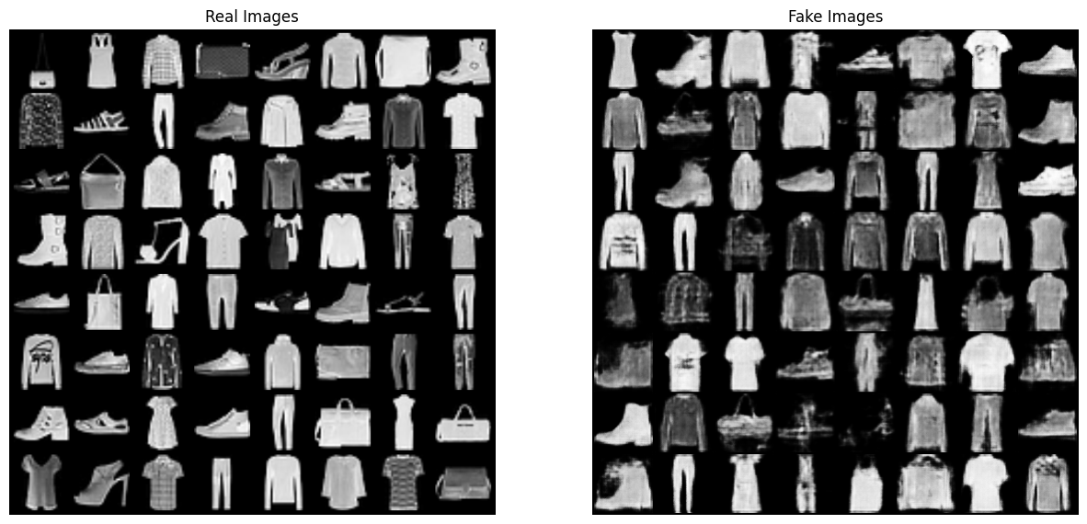

Architecture 1 Generator Loss
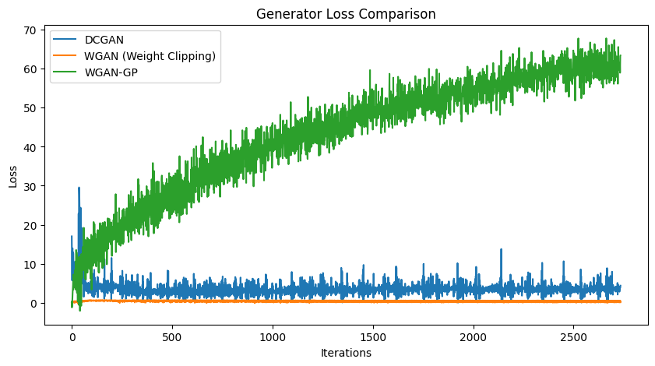
Architecture 1 Discriminator / Critic Loss
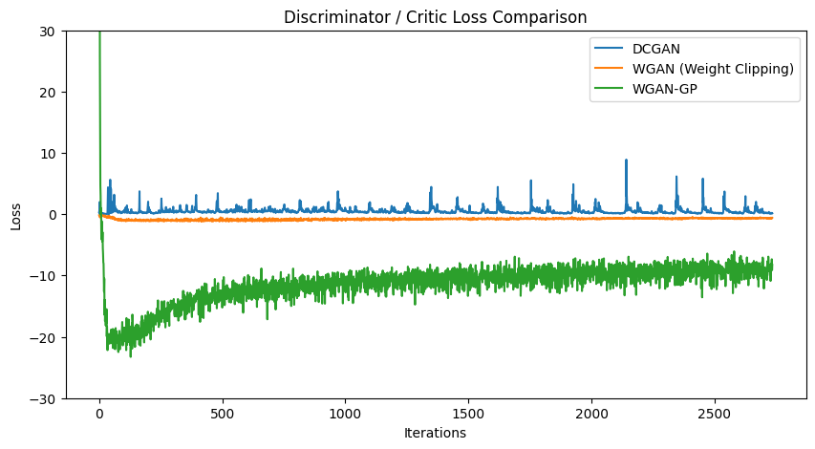

Architecture 2

DCGAN Images
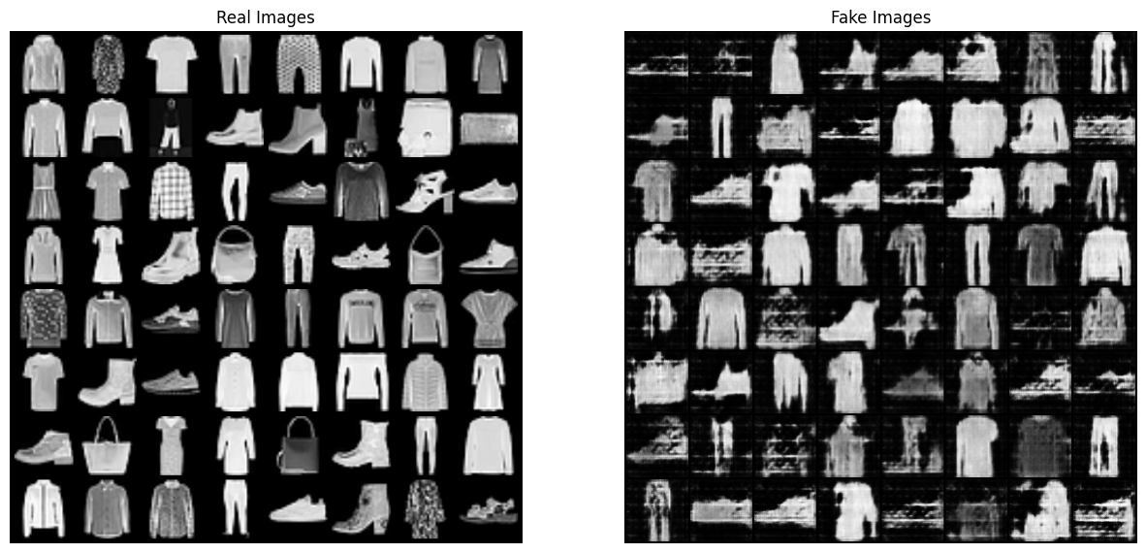
WGAN (with weight clipping) images
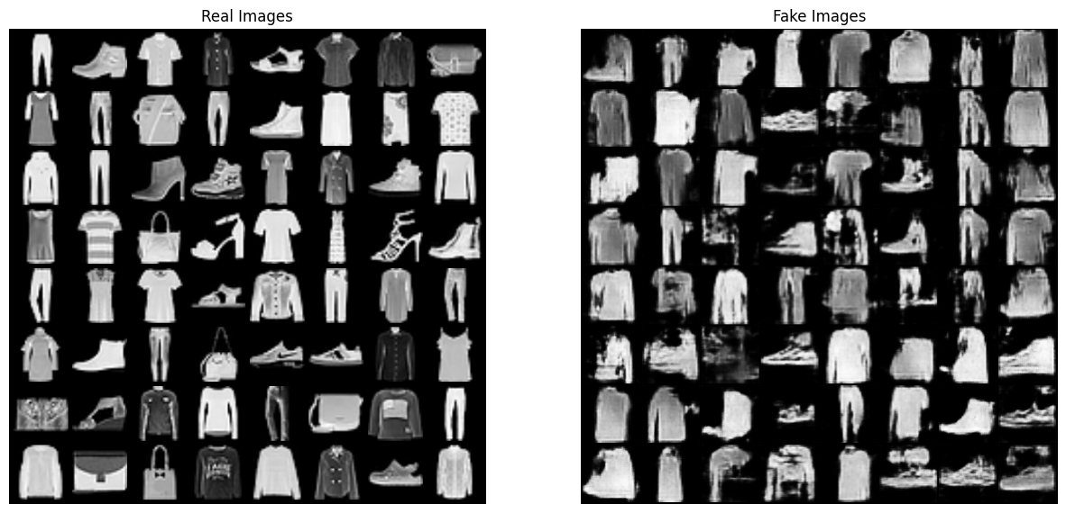

WGAN-GP (with gradient penalty) images

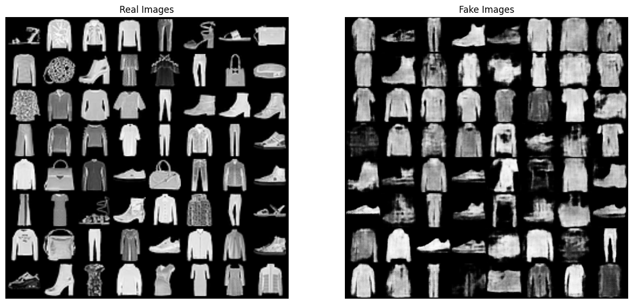

Architecture 2 Generator Loss
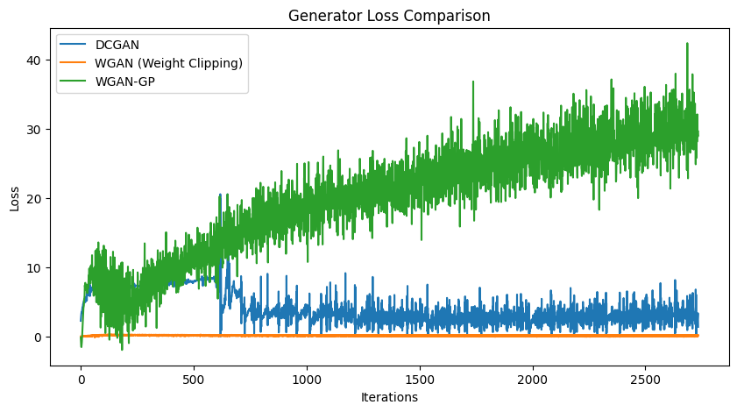
Architecture 2 Discriminator / Critic Loss



Better Performing Architecture Generation

Architecture 1, with a greater base filter count of 64 for both the generator and discriminator / critic seems to outperform architecture 2, which only differs in having a lower base filter count of 32 for both the generator and discriminator. Below are Images generated by Architecture 1 compared to true images of the same class. These results seem to show that the WGAN-GP model produces the best fake images of clothing from the FashionMNIST dataset.

True Images
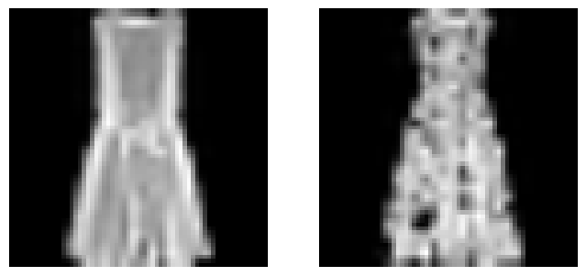
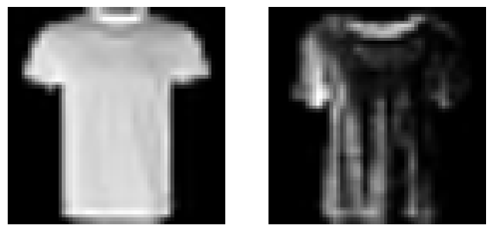

DCGAN shirts
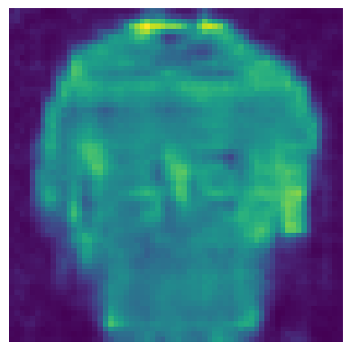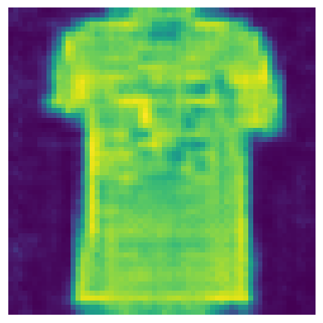
DCGAN dresses
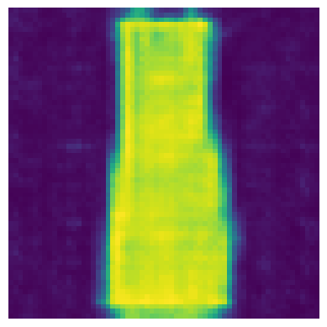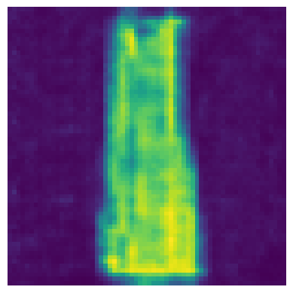

WGAN (weight clipping) shirts
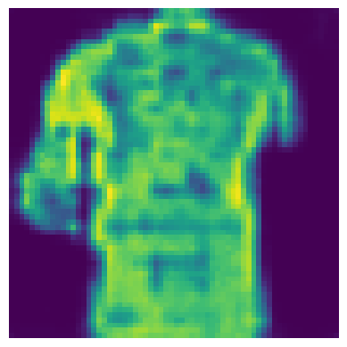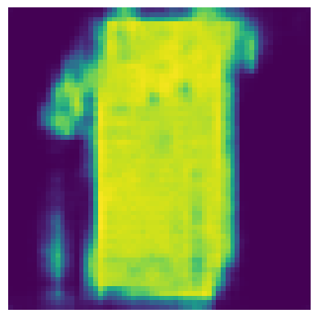
WGAN (weight clipping) dresses
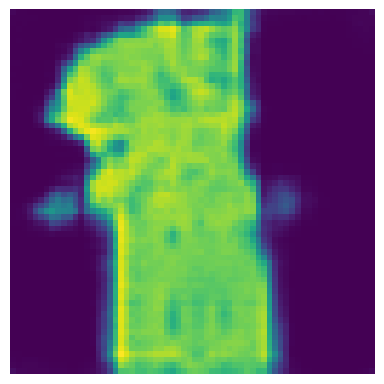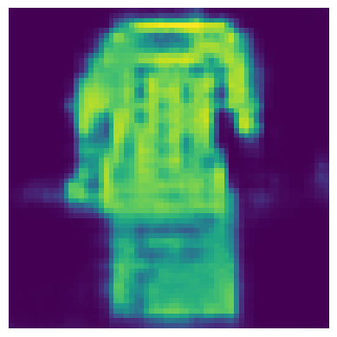
WGAN (gradient penalty) shirts

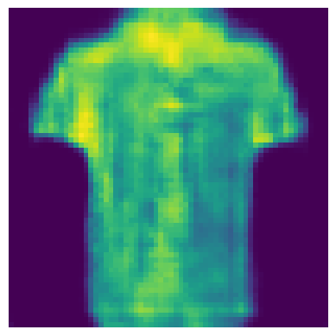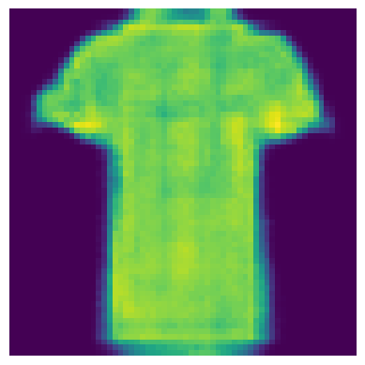

WGAN (gradient penalty) dresses

